
Amin khan
Online Retail II
Step-by-Step Data Analysis Documentation

Exploratory Data Analysis Report
Dataset: online_retail_II.xlsx

Online Retail II: Step-by-Step Data Analysis Documentation
This document provides a detailed, step-by-step guide to the exploratory data analysis (EDA) conducted on the Online Retail II dataset (online_retail_II.xlsx). It contains the implementation details, explanations, and corresponding screenshots for each task.

Task Overview
- Dataset: online_retail_II.xlsx (containing sheets Year 2009-2010 and Year 2010-2011)
- Type: Observation-Only (No data was cleaned, removed, or filtered during this analysis)
- Outputs: Jupyter Notebook containing all computations, premium visualizations, and business insights.

Step-by-Step Documentation

Step 1: Loading the Dataset & Displaying Basic Information
- Implementation:
- Imported libraries: pandas, numpy, matplotlib.pyplot, seaborn, and openpyxl.
- Loaded both Excel sheets (Year 2009-2010 and Year 2010-2011) using pd.read_excel().
- Merged them into a single dataframe using pd.concat() to analyze the full 2-year timeline.
- Calculated Revenue = Quantity * Price to facilitate financial analysis.
- Displayed shape, column list, data types, and head of the combined dataset.
- Explanation:
- Checking the structure helps us understand the format of columns. The combined dataset contains 1,067,371 rows and 8 columns (excluding index and newly added Revenue column). Column data types are mostly objects (strings) and numerical fields (int64/float64).
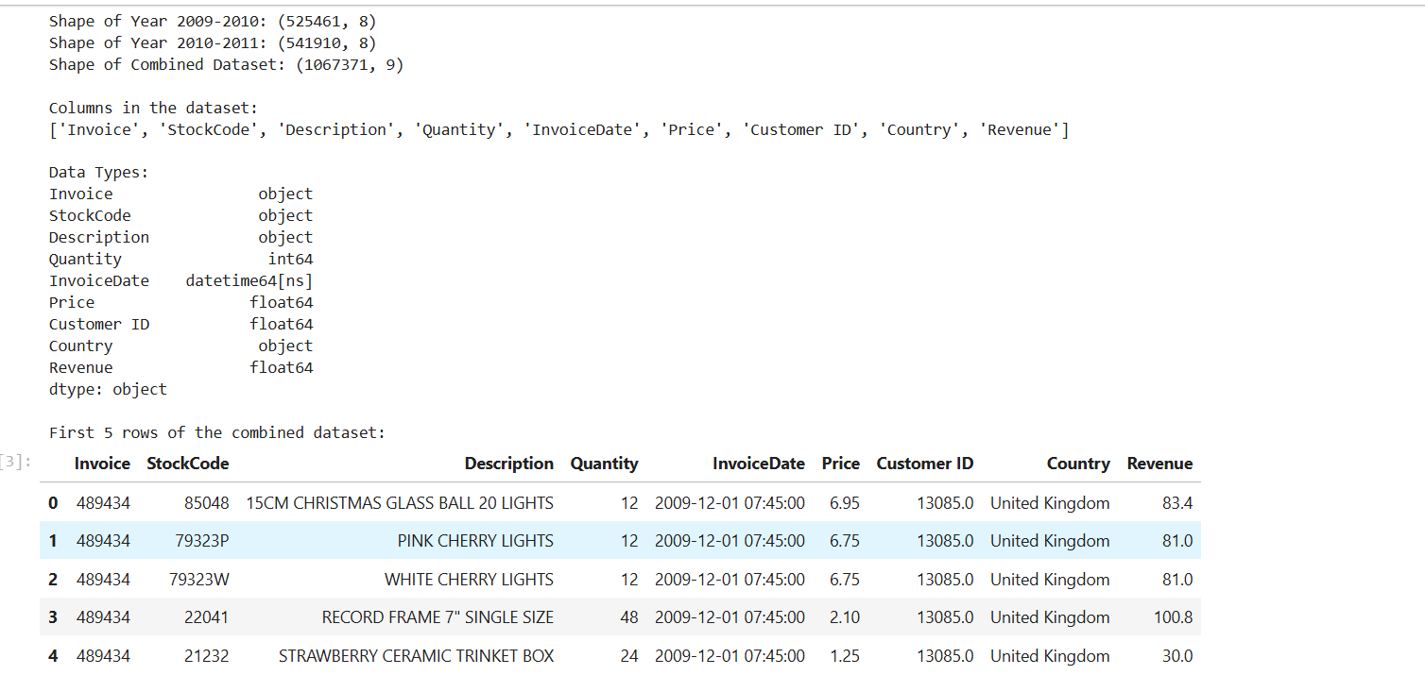
Figure: Step 1 Output: Basic Info and Structure

Step 2: Identifying Missing Values and Duplicate Rows
- Implementation:
- Found null values using df.isnull().sum().
- Calculated missing percentages by dividing by the length of the dataframe.
- Detected duplicate rows using df.duplicated().sum().
- Explanation:
- There are missing values in two columns: Description (4,382 nulls, 0.41%) and Customer ID (243,007 nulls, 22.77%).
- The dataset has 34,335 duplicate rows (3.22% of total rows). Since the task is observation-only, these are reported but not removed.
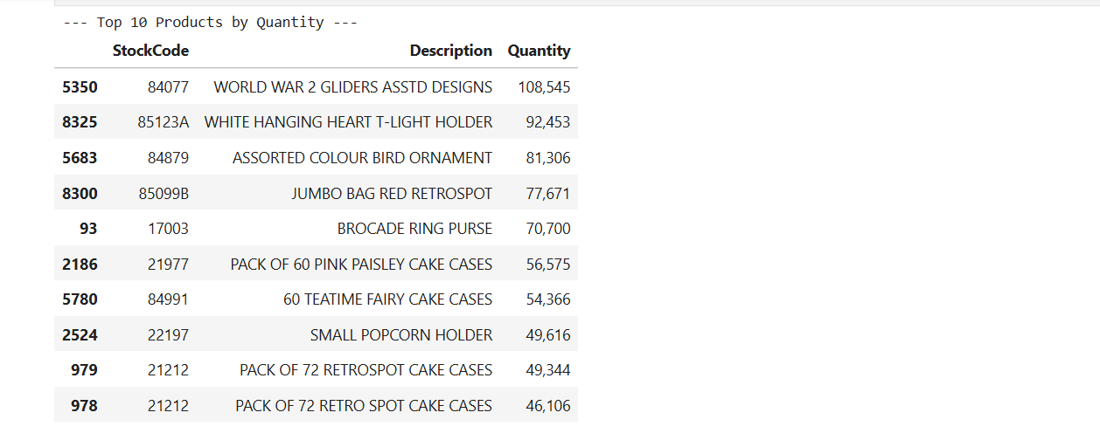
Figure: Step 2 Output: Missing Values and Duplicates

Step 3: Top 10 Best-Selling Products
- Implementation:
- Created a copy of the dataframe and filled missing descriptions with "UNKNOWN PRODUCT" for accurate grouping.
- Grouped by StockCode and Description.
- Calculated the top 10 products by Quantity (sum of Quantity) and Revenue (sum of Revenue).
- Explanation:
- The best-selling product by quantity is "WORLD WAR 2 GLIDERS ASSTD DESIGNS" with 108,545 units sold.
- The best-selling product by revenue is "REGENCY CAKESTAND 3 TIER" generating $327,813.65, followed by "DOTCOM POSTAGE" (shipping adjustments) generating $322,647.47.
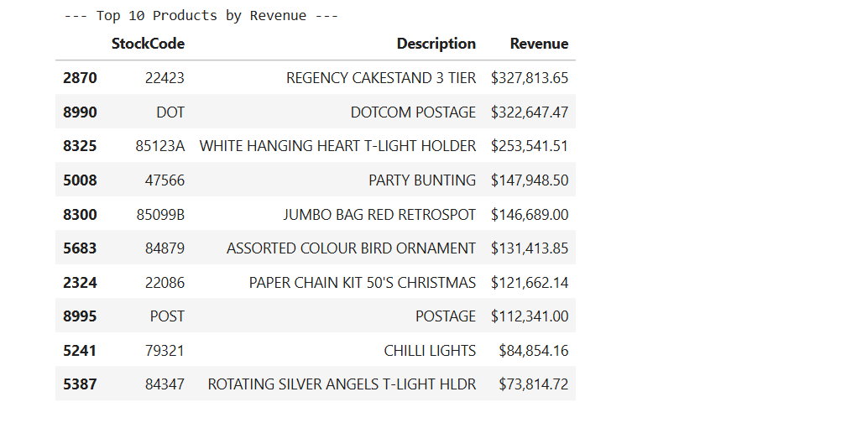
Figure: Step 3 Output: Top 10 Products

Step 4: Sales Performance by Country
- Implementation:
- Grouped data by Country.
- Calculated total quantity, total revenue, and unique transactions (number of unique Invoice values) for each country.
- Sorted the countries in descending order of total revenue.
- Explanation:
- The business is heavily centered in the United Kingdom, which generates $16.38M (approx. 92.3% of the total revenue) across 49,108 unique transactions.
- EIRE and the Netherlands follow as the next largest markets with ~$615k and ~$548k in revenue, respectively.
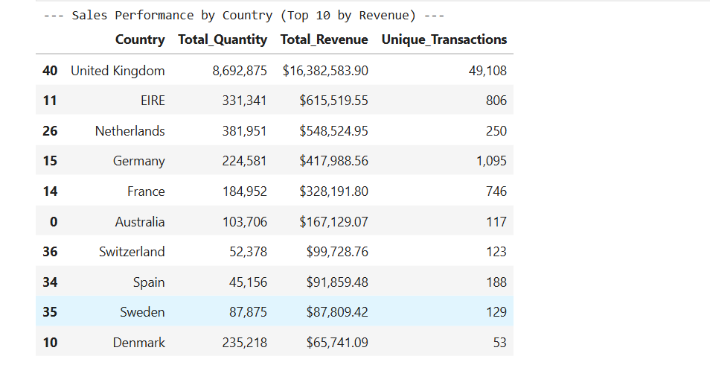
Figure: Step 4 Output: Sales Performance by Country

Step 5: Revenue Over Time (Monthly Trend)
- Implementation:
- Formatted InvoiceDate to a YearMonth period.
- Grouped by month and summed the revenue.
- Plotted a line graph with marked data points using matplotlib.
- Labeled the final data point (December 2011) as a "Partial Month" because it only includes data up to December 9th.
- Explanation:
- There is a clear and strong seasonal spike in November 2010 ($1.42M) and November 2011 ($1.46M). This represents holiday season pre-orders.
- The lowest full months are January and February, representing the post-holiday sales dip.
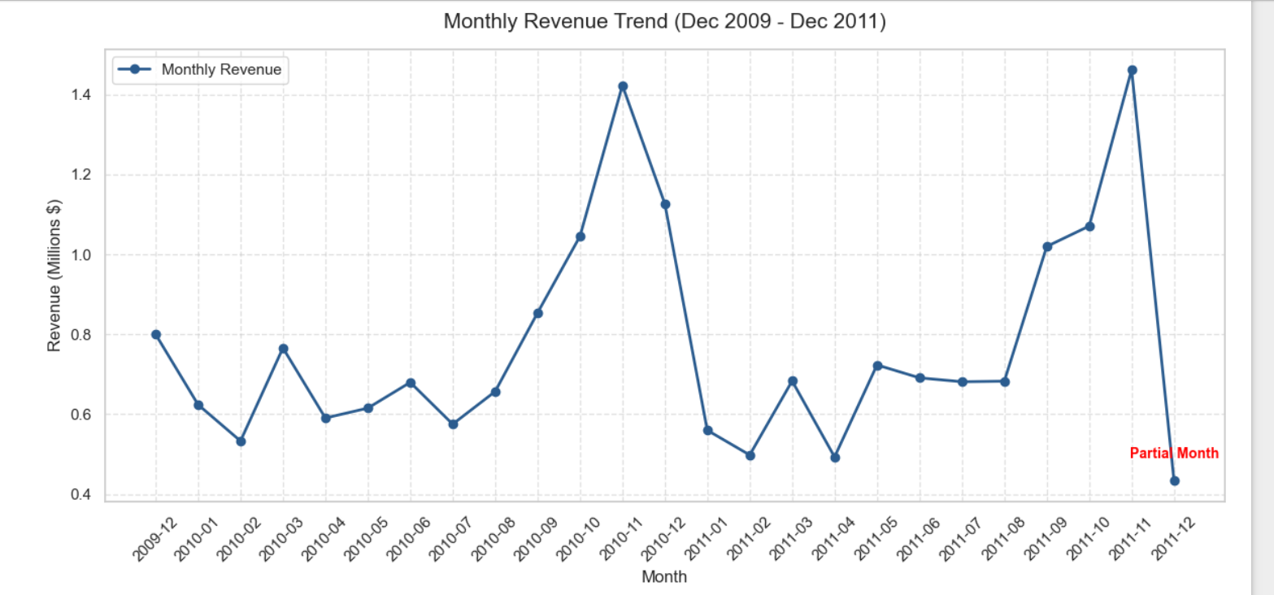
Figure: Step 5 Output: Monthly Revenue Trend

Step 6: Correlation Heatmap
- Implementation:
- Computed the Pearson correlation matrix for numerical features: Quantity, Price, Customer ID, and Revenue.
- Visualized the matrix using sns.heatmap() with annotated cell values and a coolwarm color palette.
- Explanation:
- Revenue has a high correlation with Quantity (0.7626), indicating that the volume of items sold drives overall revenue.
- Correlation between Quantity and Price is near zero (-0.0013), and Price has a very low correlation with Revenue (0.0610). This shows that revenue growth is volume-driven rather than price-driven.
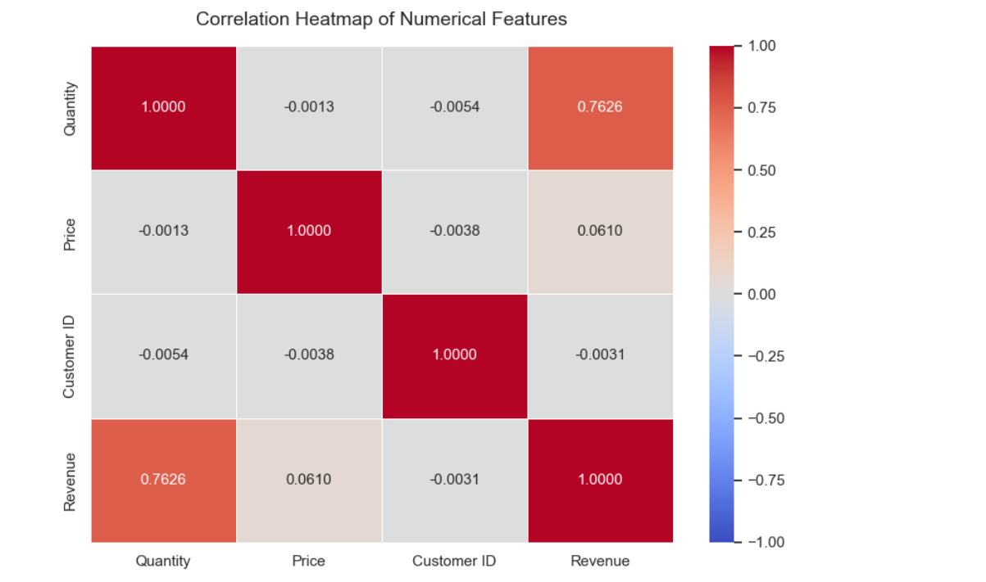
Figure: Step 6 Output: Correlation Heatmap

Step 7: Outlier Detection and Visualization
- Implementation:
- Created a 2x2 grid of box plots using matplotlib and seaborn.
- Plotted Quantity and Price distributions on a Full Scale (top row) to show extreme outliers.
- Plotted Quantity and Price on a Zoomed-in Scale (bottom row) to inspect the core interquartile ranges and median.
- Explanation:
- Outliers in quantity and price are extremely prominent.
- The largest quantity outliers represent massive order cancellations (e.g. order of 74,215 and its matching cancel of -74,215).
- The largest price outliers represent administrative fees and debt corrections (e.g. Amazon Fees and Bad Debt adjustments exceeding $10,000).
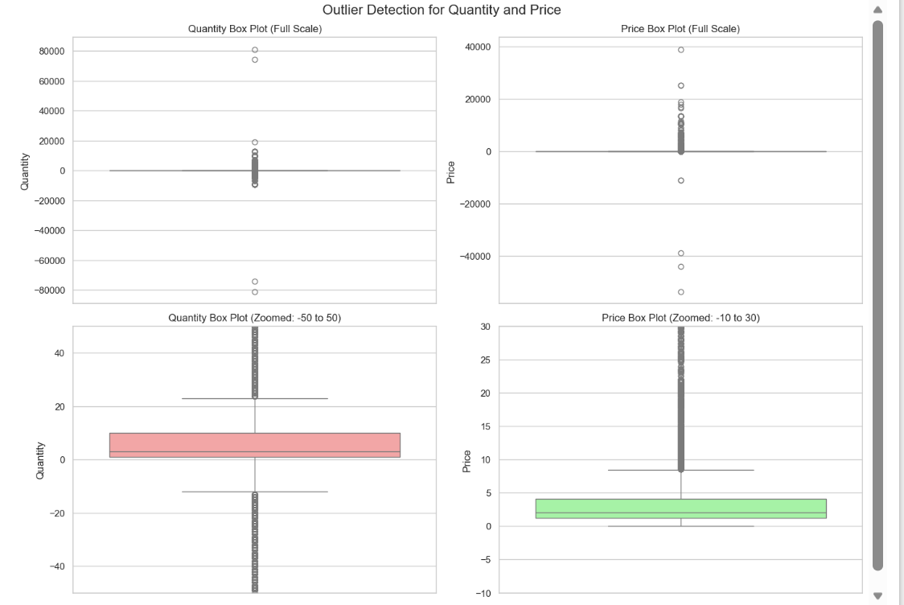
Figure: Step 7 Output: Outlier Box Plots

Summary of Business Insights
- Bulk Order Cancellations: Symmetrical extreme quantity outliers (like orders of 74k and 80k units and their immediate reversals) suggest order-entry errors or test transactions. Guardrails should be placed in order systems.
- Administrative Adjustments in Sales Data: Large adjustments (AMAZONFEE, M for Manual, B for Bad Debt) skew basic transactional metrics and must be filtered out for standard retail reports.
- Holiday Seasonality: Sales show highly predictable seasonal surges peaking in November. Supply chain and inventory stocking should prepare for these surges starting in August/September.
- Market Concentration Risk: Over 92% of the sales revenue originates in the UK. Geographic diversification into European countries (like Germany, France, Netherlands) presents expansion opportunities.
- Volume-Driven Revenue: Revenue is highly correlated with Quantity (0.76) and not Price (0.06), indicating that bulk sales and volume are the main business drivers.

